Compass Maritime LLC, Valuing Ships

Prepared for

Dr. Chuanren Liu

Drexel University

Prepared by:

Drashti Shah

Mayuresh Wani

Parag Paliwal

Rohan Jain

Vinay Gandhi

December 2018

Summary

This report summarizes the statistical models and analysis associated with Compass Maritime Services, LLC study. The purpose of this report is to document both the implemented model and all corresponding modeling and inference techniques used during the analysis for the valuation of the ship. The final developed model and the process through which it was finalized is discussed along with the final value of ship predicted. The importance of different variables and its relationship with the value of the ship is mentioned.

Introduction

Compass Maritime Services, LLC is a New Jersey based firm specializing in the sale and purchase of ships and offshore vessels, valuations, recycling and demolitions of ships, shipping research and consulting. In the case provided Compass Maritime Services are assisting a potential client in assessing a value and making an offer on a ship.

The company and management: Tom Roberts is the founding member of Compass Maritime Services and Basil Karatzas is the director for projects and finance. Basil Karatzas is the key person responsible for advising clients on sale and purchase transactions, it is his responsibility to identify an appropriate ship, a reasonable price to offer and some suggestions regarding the negotiation strategy.

About the Bet Performer: It was an 11 years old ship which was built in 1997, had a capsize bulk carrier of 172,000 deadweight tons (DWT). This ship had a Burmeister & Wain (B&W) 6S70MC Engine, had nine holds and hatches and was built by Nihon Kōkan KabushikiKaisha (NKK) in Japan (1997). 2 years ago, it was sold for $70 million. The current owners have expressed an interest to sell this ship through communication.



The above picture is what the Bet Performer looked like.

Methodology

Ship Valuation:

In order to suggest the best sale price to the client, we created five models taking different variables into consideration. The models were built using various parameters from a dataset which was provided. The one with the highest confidence was chosen and suggested to the client. The five models are as explained below. Linear regression is used in the approaches for all the models.

Model 1:

The variables taken into consideration to determine the sale price of the ship was only the year in which the ships were built. The variation in the sale prices of the ships was observed from the year in which they were built. From the observations, they should a linear relationship with each other. The visualization of that model is as shown below.

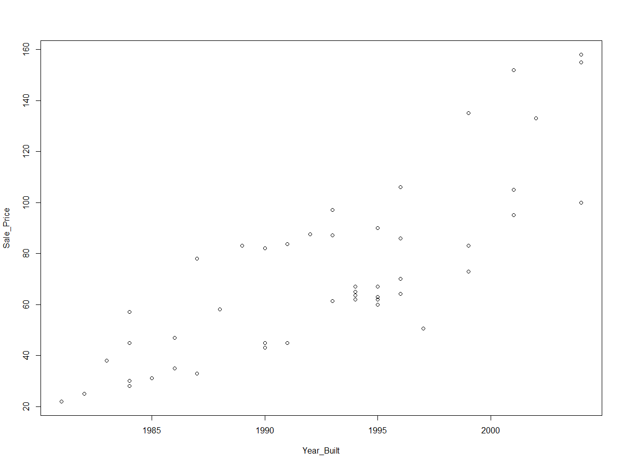

Fig. 1

Although the p-value of this model was less, it did not give a precise sale price of the ship when other variables from the dataset were taken into consideration.

Model 2:

The variables taken into consideration to determine the sale price of the ship were – the year in which the ships were built and the age at which they were sold. The relationship between these variables was observed and the p-values and the adjusted r squared values were noted. It turned out that as compared to the first model, it had a p-value which was even more close to zero and a higher adjusted r square value. It gave a more accurate selling price as compared to the previous model. The visualization is as shown below.

Model 3:

The variables taken into consideration to determine the sale price of the ship were the year in which the ships were built, the age at sell and the DWT. This model was more precise than the previous two models and gave a better picture of the sale price of the ship. The p-value was even lesser than that in model 2 and the adjusted R^2 value was even higher. The visualizations of this model are as shown below.

Model 4:

In this model we have taken, sale price of the ship, sale years, weight, capesize and the year in which it was built. We added capsize index to our model, which was not there in the previous models.

Capesize Index: The index provides composite measure of charter rates across ship types and market. Higher charter rates reflect higher index and a high index means greater value of the ship. High charter rate is reasoned by blooming global economy, increased demand for exports from and imports to China and shortage of ships.

Here the adjusted r2 is high, but if we look at year built, the confidence level is close to 85% as reflected in its p-value. To further improvise the confidence level, we did changes in our model. We built our final fifth model which gave us the most precise value for the sale price of the ship and hence this price was chosen to suggest the client.

Model 5:

The parameters which were considered to estimate the sale price of the ship were the age at sell, DWT and the Capesize index of the ship. This model gave us the required results with a confidence level of 95%. The confidence interval ranged from 125.82 million to 133 million dollars. So, the minimum amount at which the ship would have been sold was $125.8 million. The visualizations for this model are as shown below.

Conclusion and Recommendations:

For the Bet Performer, our regression model predicted value of the ship to be $125.8 million, with a 95% confidence interval between $118.8 and $132.7 million.

We have used the linear regression approach that uses ship age (Years), deadweight tons (1000s) and economic data in the form of the trailing 1-Year Baltic Capesize index.

The predicted price being an estimate might be subject to increase or decrease in case of additional information the client may have (e.g. Ship Conditions, shipyard (original builder), location, etc)

Appendices

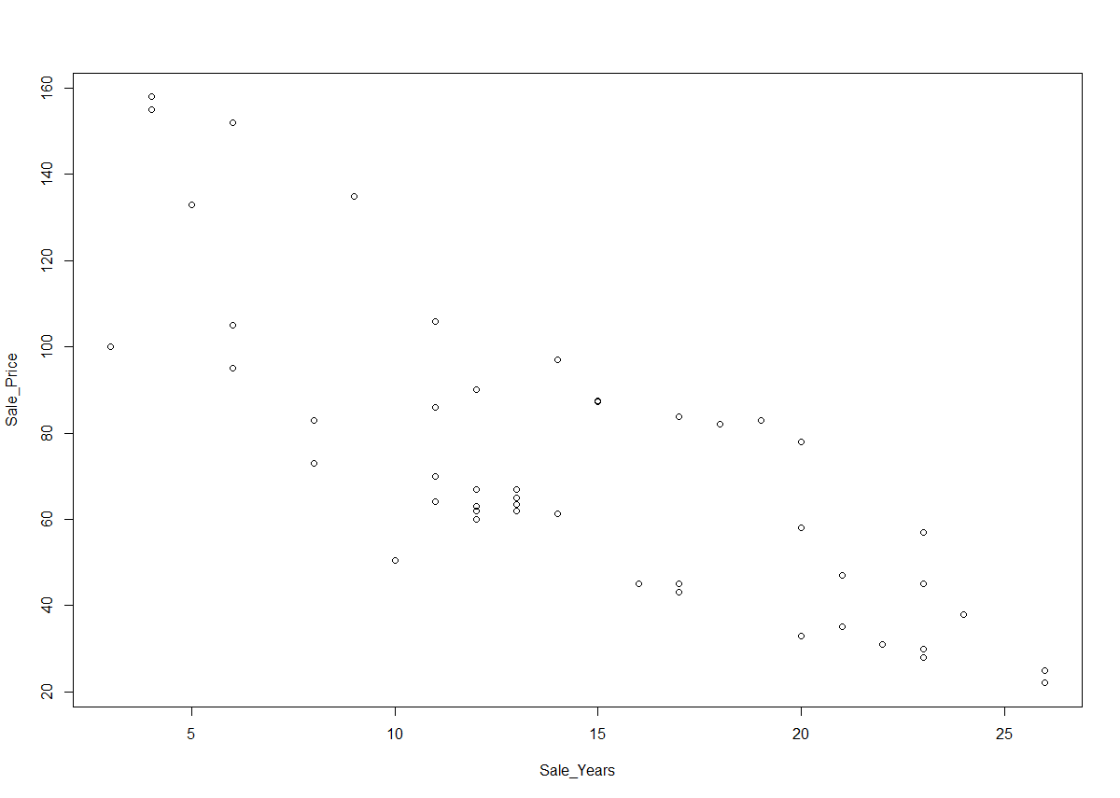

Fig. 2

Figure 2 is a graph between sale prices and sale years, which shows that price with lower the sale years higher the price.

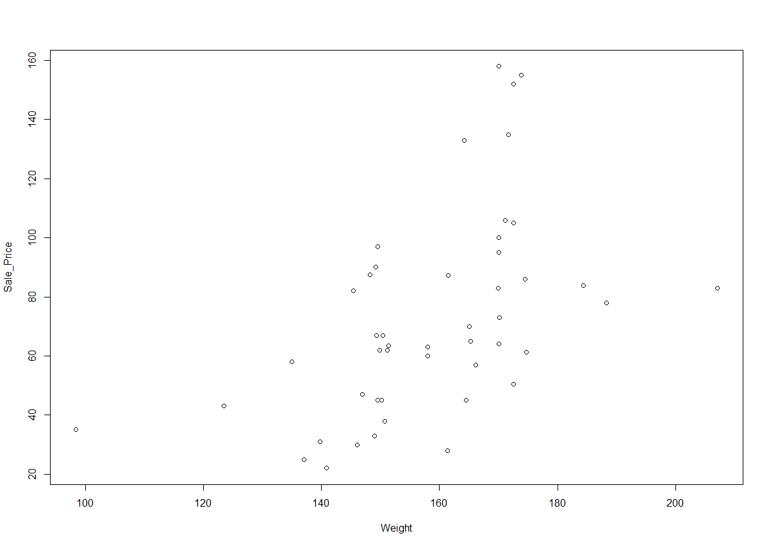

Fig. 3

Graph of Sale Price vs Weight i.e. Dead Weight Ton

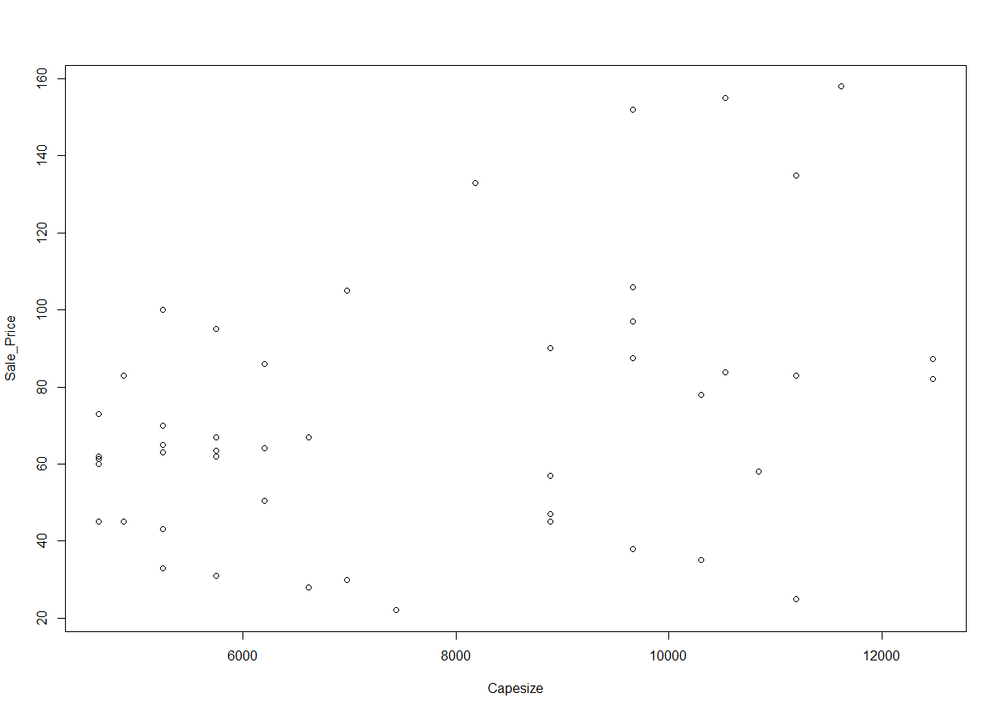

Fig. 4

Capesize vs Sale Price